KEPServerEX Features 

Introduction
It is very common to hear the term "client/server application" in use across many software disciplines and business segments. In the industrial market, it has often come to mean the sharing of manufacturing or production data between a variety of client applications ranging from human machine interface software and data historians, to large MES and ERP applications. In order for client applications to get data, they must connect to a server that will retrieve it for them in a standard form. The problem is that there are many devices and systems in the industrial market that you might want to get data from, but each may speak a different "language" or protocol. It is here that Kepware’s KEPServerEX comes into play. The KEPServerEX's job is to get device and system data and translate it into a standard communication protocol (OPC or DDE) that all clients can receive and understand.
What is KEPServerEX
KEPServerEX is the latest generation of Kepware's OPC server technology. It was designed to allow you to quickly setup communications to your control systems via a wide range of available "Plug-in" device drivers and components. With over 80 downloadable drivers that support hundreds of model types, getting data to you client is a snap. The KEPServerEX also provides a common and self-evident user interface across all drivers so that you feel at ease every time you use the product no matter what driver you use. You can add many devices utilizing multiple drivers all within the KEPServerEX interface without worrying about learning new communication protocols or spending time understanding new applications.
KEPServerEX Plug-in OPC Drivers and Components
A "Plug-in" is a software program that extends the capabilities of KEPServerEX to fit the communication requirements of a specific device.
KEPServerEX Features
KEPServerEX is the latest generation of our OPC server technology. Building upon the original KEPserver, KEPServerEX has incorporated many of the features requested by our customers. In addition to customer driven enhancements, many technological changes have occurred. These features and enhancements have all been made with the goal of providing an OPC server that demonstrates unparalleled compatibility and performance.
A few of the enhancements are transparent to the user, but there are a number of new features that are readily apparent and directly available to the user. The following sections will describe the primary features of KEPServerEX.
Application Connectivity

KEPServerEX has been enhanced to provide the widest range of connectivity of any server product available. KEPServerEX supports the following client server technologies:
OPC Data Access Version 1.0a
OPC Data Access Version 2.0
OPC Data Access Version 2.05a
FastDDE for Wonderware
SuiteLink for Wonderware
DDE Format CF_Text
DDE Format AdvancedDDE
OPC Data Access 1.0a was the original specification the OPC Foundation developed back in 1996. Many of the OPC client applications in use today support this original specification. OPC Data Access 2.0 is the latest version of the OPC interface. The 2.0 version of the interface has been enhanced to make better use of the underlying Microsoft COM technology. Most OPC client applications are being converted to support version 2.0 of the OPC specification. The DDE format CF_Text is the standard DDE format as defined by Microsoft. All DDE-aware applications support the CF_Text format. AdvancedDDE is a variation on the normal CF_Text format. Advanced DDE allows larger amounts of data to be transferred between applications at higher rates of speed, and with better error handling than a normal CF_Text DDE link. FastDDE/SuiteLink format provides native support for Wonderware Factory Suite products. In keeping with Kepware's goal of providing the broadest range of connectivity, KEPServerEX simultaneously supports all of the client server technologies listed above. Client applications using any of these technologies can access data from KEPServerEX at the same time.
Based on Microsoft's COM technology, OPC servers can share data with remote client applications using DCOM(Distributed COM). DCOM allows you to use a single OPC server to provide data to client applications running both locally and on remote machines. DDE is not without its own means of allowing remote access. All of the DDE formats supported by KEPServerEX can also be accessed remotely using what is known as NETDDE. NETDDE allows a remote DDE client application to use the machine name of a remote DDE server when specifying a DDE link. KEPServerEX has been designed to allow both of these methods of remote server access. In terms of OPC connections, KEPServerEX will properly configure your DCOM settings to allow remote OPC clients to access and browse KEPServerEX. For DDE clients, KEPServerEX will automatically start NETDDE services and register all of the required DDE shares to allow remote DDE clients to access device data. Establishing DDE share names can be a time consuming process with this in mind, NETDDE services are not enabled in KEPServerEX by default.
Device Connectivity

KEPServerEX is somewhat unique in its approach to providing OPC connectivity for a number of devices. In most cases OPC servers are written as single function programs that can handle only a single device type or protocol at a time. The result is that multiple OPC servers are required to handle a range of devices and protocols. KEPServerEX is written as two separate components. The server component (KEPServerEX) houses all of the user interface and OPC technology. Device specific drivers plug into this server component. If only one communications driver could be plugged into the server at a time then we would have gained nothing. KEPServerEX allows you to use a number of communications drivers concurrently.
Notice in the figure below that we have configured KEPServerEX to communicate with Allen Bradley, General Electric, Mitsubishi and Siemens Devices using the one server interface. Also notice that you can configure multiple devices (Mitsubishi) under one channel.
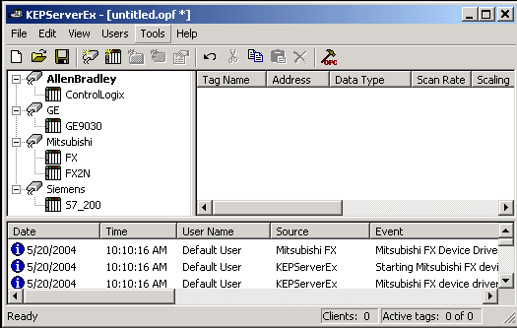
Click here to find out what plug-in communications drivers are available for KEPServerEX.
If you are having trouble connecting the server to your device, read the Device Connectivity Trouble Shooting Guide for some tips on what could be the cause of your connectivity issues.
CSV File Import and Export

The server supports the import and export of tag data in a CSV (comma separated variable) file. The CSV functions are only available when a Device or Tag Group is selected. Using CSV import and export, tags can be created quickly in the application of your choice.
Important Note: The easiest way to create an import CSV file is to create a template using File|Export CSV. Define the channels and devices that the project will contain. Next define a tag for each device. Export each device or tag group as a CSV file. Use this template in a spreadsheet application that supports CSV files and modify the file. The resulting CSV file can then be saved to disk and imported back into the server under the same device or tag group or under a new device or tag group.
Exporting a Server Tag List:
This generates a .CSV (comma separated variable) text file that contains a heading record followed by a record for each tag defined under the selected device or tag group. The heading record contains the following fields.
Tag Name - Name of the tag as it will be referenced in an OPC client.
Address - The device location referenced by the tag.
Data Type - The data type used for the tag as shown in the server Tag Data Type drop down list box.
Respect Data Type - This forces the tag to follow its defined data type not the OPC client request.(1, 0)
Client Access - Read/ Write access (RO, RW, WO)
Scan Rate - The rate in milliseconds that the tag address will be scanned when used with most non-OPC clients.
Scaling - Scaling mode (Linear, Square Root)
Raw Low - Low raw value
Raw High - High raw value
Scaled Low - Scaled low value
Scaled High - Scaled high value
Scaled Data Type - The data type used for the tag after scaling is applied.
Clamp Low - Force the resulting scaled value to stay within the limit of Scaled Low.(1, 0)
Clamp High - Force the resulting scaled value to stay within the limit of Scaled High.(1, 0)
Eng. Units - Units string.
Description - Tag description
Each tag record contains the data for each field in a tag record.
Microsoft's Excel makes an excellent tool for editing large groups of tags outside of the server. Once a template CSV file has been exported is can be loaded directly into Excel for editing. A CSV file load in Excel would appear as follows:
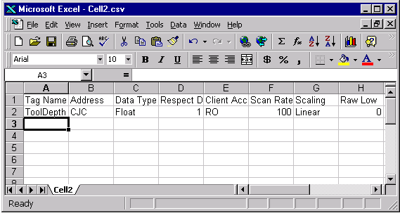
Importing a CSV tag list into the Server
Once you have finished editing your tag list it can be imported back into the server using the import CSV function File|Import CSV. This option is available only when you have either a device or tag group selected.
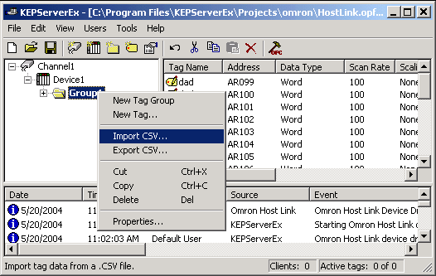
Running as an NT Service

The server supports running as a service under Windows NT/2000/XP/Server2003. Service operation is completely user configurable from the Tools|Options menu and can be changed at any time allowing you to move from normal stand-alone program operation to NT service mode. Running as an NT service is crucial for many applications where the server provides data to OPC clients via DCOM. For these applications a loss of DCOM connection cannot be tolerated. Normally an OPC server that only supports stand alone program operation is forced to shut down when its host machine experiences a user log in or log out. While running as a service, the server can continue to supply OPC data across user log in sessions and can be configured to interact with the desktop allowing you to make changes to your server project. It can also be configured to have a visible presence while running, which allows you to make changes to your project while running.
To run the server as a service, select (on the Service tab) the Tools|Options menu.
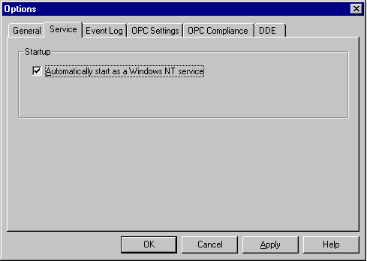
The "Automatically start as a Windows NT service" option allows you to configure the server for operation as a service under Windows NT/2000/XP/Server2003. By default this option is disabled (unchecked). When you enable the service option you will be presented with a message dialog warning you that this change will take effect on the next server run. If you want the server to immediately become a service you must exit the application. Once you have exited the server you can either restart it from the Windows NT Service Manager found on the "Control Panel" or allow your OPC client to invoke the server when it connects.
Note: The Service option of the server can only be accessed when you are logged into Windows NT/2000/XP/Server2003 as an administrator. If you are currently logged in as a normal user the run as service option will be disabled (grayed out).
Once you have configured the service option, you may also need to modify the NT service options to setup the server for your specific application. Here is the NT Service Manager's properties dialog for the server showing its default conditions:
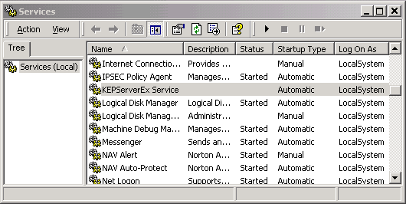
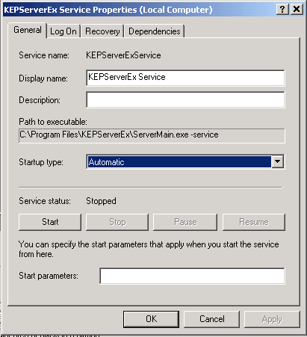
By default the server is configured for automatic startup and interaction with the desktop. Interaction with the desktop means that you will still see the server on your task bar and that you will be able to make changes to your server project even though it is running as a service. However, you will not be able to shut the server down from any of the normal menu exits or close functions. Allowing the server to interact with the desktop has no effect on its ability to supply OPC data across user logins. Once you have your server project completely configured you may want to consider disabling the server's interaction with the desktop. This will prevent users from seeing the server on their task bar and further reduce unauthorized access to the server. To prevent the server from interacting with the desktop simply uncheck the "Allow Service to Interact with Desktop" check box. Once you disable desktop interaction you will need to restart the server to remove it from your system taskbar.
Note: We strongly recommend that while you are running the server in a demo or evaluation mode that you continue to allow the server to "Interact with Desktop". This will allow you to see any error messages that the server may generate such as "Demo period has expired". If this occurs simply stop the service using the Service manager as shown below.
Once the server is configured to run as a service you can use the NT Service manager to manually start and stop the server. The Service Manager menu allows you to select your server by name and either start or stop the service as shown here:
Returning the Server to Normal Program Mode
To return the server to normal stand alone program operation you must first be able to interact with your server project. This requires that the server be able to interact with the desktop. If you do not have the server configured to interact with the desktop, use the NT Services Manager to enable desktop interaction then stop the server service. Once the server has stopped, restart it using the Start button as shown above. You should now be able see the server on your system taskbar. Once the server can be seen on the desktop you can make changes to your server project. To return to normal program mode uncheck the "Automatically start as a Windows NT service" checkbox on the Service option dialog of the server. Next, stop the server using the Stop button of the Service manager. Now you should be able to run the server from your normal desktop icon or start menu selection.
If the server is configured to run as a service and you attempt to run it from your desktop icon or the start menu you will be presented with the following message box:
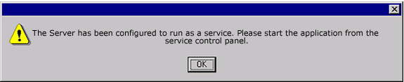
If you receive this message and truly require the server to run as a normal program review the steps in "Returning the Server to Normal Program Mode" above.
Possible issues when running as a service
Under most circumstances you should be able to seamlessly switch between Service mode and Stand Alone mode. There is the possibility of a DCOM (Distributed Component Object Model) security issue that may prevent your OPC client from being able to connect to the server when it is running as a service.
If you experience an issue connecting your OPC client to the server when it is running as service, we suggest that you first take the server out of service mode and confirm your OPC connection in Stand Alone mode. Once you have confirmed your OPC client connection under normal circumstances it's time to look at your DCOM settings.
Data Scaling

KEPServerEX now supports direct scaling of device data. Scaling allows raw device data to be converted to engineering units for OPC client applications. KEPServerEX provides a number of unique scaling features that make it easy to implement scaling in your application. KEPServerEX now supports direct scaling of device data. Scaling allows raw device data to be converted to engineering units for OPC client applications. KEPServerEX provides a number of unique scaling features that make it easy to implement scaling in your application.
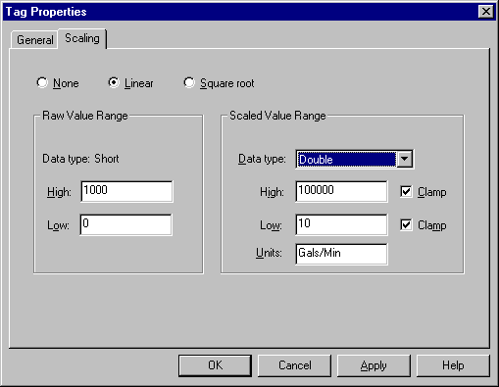
The Scaling in KEPServerEX supports Linear and Square Root formulas. You can specify the range of the raw data from your device and the engineering range of the scaled value. In some cases the raw data received from a device may exceed the range set for the raw data. If this occurs the engineering value can be forced outside of the range you desire. To prevent this, KEPServerEX allows you to specify that the scaled value be clamped to the engineering ranges. In most cases it is always assumed that a scaled value results in a floating point number. KEPServerEX doesn't make this assumption and allows you to select the scaled engineering value to be any valid OPC data type. This means you can scale a 16 bit integer value to a 32 bit integer value. "Double" is the default data type for all scaled values. To make scaling complete, KEPServerEX allows you to specify the units for the scaled tag. A string of up to 32 characters can be entered and attached to the tag. If the OPC client application in use supports access to OPC tag properties, the data ranges and the units can be used in the OPC client to automatically configure objects like user input or data displays.
More KEPServerEX Features

On-Line Full Time
On-line KEPServerEX is on-line all the time. To acquire data from a PLC or device, a channel and device must be configured in the server, and a client application must be requesting data. The full time on-line mode of operation allows a KEPServerEX project to be modified while the server continues to supply data to client applications. Almost every parameter can be changed while the server is operating. Parameters like communication port or baud rate can be changed while a client application is active, if needed. More importantly, user defined tags can be added to the server without shutting down client applications. When new tags are added to the server, they are immediately added to the OPC browse space, and will be available to OPC clients.
User Management
With a powerful feature like on-line full time operation, managing what your users can do in your OPC application becomes a necessity. KEPServerEX includes a built-in User Manager that allows complete control over what types of functionality each individual user can access. The default administrator account allows you to add multiple users, each with their own set of rights for server access. Any user action that can influence or disrupt server operation is logged to KEPServerEX's event logging system. By default, all server operations are available at all times. The User Manager functions of KEPServerEX are available only if you need them.
Tag Management
KEPServerEX's new user defined tag management features allow you to create a tag database structure that fits the nature of your application. Multiple tag groups can be defined to segregate your tag data on a device-by-device basis. Drag and drop editing makes adding large numbers of tags easy. Additionally, CSV import and export allows tag editing to be done in any application you desire. Like all other features in KEPServerEX, new tags can be added to your application at any time.
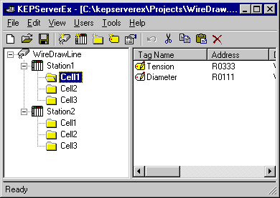
Network Interface Selection
KEPServerEX allows you to specifically select a NIC card for use with any Ethernet driver or serial driver running in Ethernet Encapsulation mode. The Network Interface feature allows you to select a specific NIC card based on either the NIC name or its currently assigned IP address. This list of available NICs will include both unique NIC cards or NICs that have multiple IPs assigned to them. Additionally the selection will also display any WAN connections you may have active such as a dialup connection.
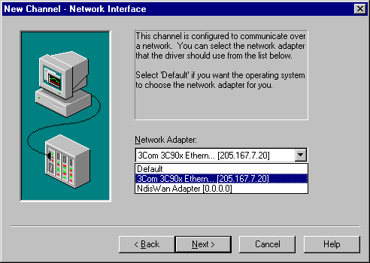
Modem Support
KEPServerEX supports the use of modems on all serial communication drivers. Modem control is provided by a set of new modem tags. Once modem operation is enabled for a KEPServerEX project, a predefined set of modem tags becomes available to client applications. The modem tags provide control of dial, dial number, hang up, and auto answer mode. Additional modem tags provide status of the modem connection. Using these modem tags, client applications can be designed to control all aspects of a modem connection. KEPServerEX's modem support allows you to extend your system management and data gathering needs beyond the control room.
For more detailed information on how to enable modem functionality, access modem tags using Kepware's OPC Quick Client, and to view an example of dial scripting in a client view our KEPServerEX Modem Example Application.
Auto-Demotion

The Device Auto-Demotion parameters allow a driver to temporarily place a device off-scan in the event that a device is not responding. By placing a non-responsive device off-line, the driver can continue to optimize its communications with other devices on the same channel by stopping communications with the non-responsive device for a specific time period. After the specific time period has been reached, the driver will re-attempt to communicate with the non-responsive device. If the device is responsive, the device will be placed on-scan, otherwise it will restart its off-scan time period.
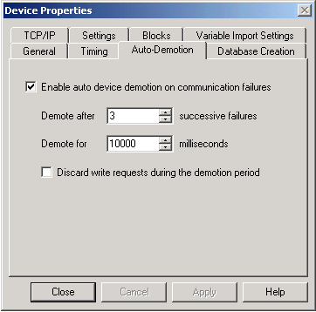
Automatic Tag Database Generation

The promise of OPC is to make the customer's life easier. With that goal in mind Kepware has added a new feature that helps bring OPC technology closer to true Plug and Play operation. The Automatic Tag Database Generation feature of KEPServerEX, available on select OPC servers, allows you to configure all of the necessary tags for your device automatically at startup, or with the simple press of a button. OPC Tag browsing is one of the key features of OPC technology. To use this feature in most cases requires the user to manually enter all of the tags required for their application. While tedious, once complete the user had the benefit of being able to point and click from their OPC client applications to link with these tags. The Automatic Tag Database Generation feature of KEPServerEX eliminates that last tedious step for OPC users. For the drivers that support it, this feature makes OPC project setup a quick and painless operation. As of 07/22 /2003 the following drivers now support this feature:
- Allen Bradley ControlLogix
- AutomationDirect Ethernet Base Controller (EBC)
- AutomationDirect ECOM
- AutomationDirect DirectNet
- AutomationDirect KSequence
- Dataforth isoLynx
- GE Fanuc Ethernet Global Data
- GE Ethernet
- GE SNP
- GE SNPX
- Hilscher Universal
- Honeywell HC900
- IDEC
- Modbus RTU Serial
- Modbus Plus
- Modbus Ethernet
- Optimation OptiLogic Ethernet I/O
- Scanivalve
- SIXNET UDR
- Thermo Westronics SV100/SV180
- Thermo Westronics Serial Communications
- WAGO 750 Ethernet I/O
- Wonderware InTouch Client Driver
- Yokogawa CX Ethernet
- Yokogawa Darwin
- Yokogawa Darwin Serial
- Yokogawa DX Ethernet
- Yokogawa DX Serial
- Yokogawa DXP Ethernet
- Yokogawa HR 2400
- Yokogawa MX
Here is an excerpt from the KEPServerEX help describing the Automatic Tag Database Generation function:
The automatic OPC tag database generation features of KEPServerEX have been designed to make the setup of your OPC application a Plug and Play operation. For communication drivers that support this feature, you can configure them to automatically build a list of OPC tags within KEPServerEX that correspond to device specific data. The automatically generated OPC tags can then be browsed from your OPC client. The OPC tags that are generated are dependent upon the nature of the supporting driver.
If the target device supports its own local tag database the driver will read the device's tag information and use this data to generate OPC tags within KEPServerEX. If the device does not natively support its own named tags, the driver will create a list of tags based on information specific to the driver. An example of these two conditions may be as follows:
A data acquisition system that supports its own local tag database. The driver will use the tag names found in the device to build KEPServerEX's OPC tags. An Ethernet I/O system that supports detection of I/O module type. The driver in this case will automatically generate OPC tags in KEPServerEX that are based on the types of I/O modules plugged into the Ethernet I/O rack. The mode of operation for automatic tag database generation is completely configurable. The following dialog allows you to configure how KEPServerEX and the associated communications driver will handle automatic OPC tag database generation:
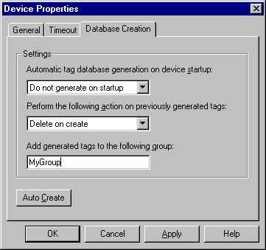
The "Automatic tag database generation on device startup" selection allows you to configure when OPC tags will be automatically generated. There are three possible selections. The default condition, "Do not generate on startup", will prevent the driver from adding any OPC tags to the tag space of KEPServerEX. The selection "Always generate on startup", will cause the driver to always evaluate the device for tag information and to add OPC tags to the tag space of the server each time the server is launched. The final selection "Generate on first startup" will cause the driver to evaluate the target device for tag information the first time this KEPServerEX project is run and to add any OPC tags to the server tag space as needed. When the automatic generation of OPC tags is selected, any tags that are added to the server's tag space must be saved with the project. You can configure your KEPServerEX project to auto save from the Tools|Options menu.
When automatic tag generation is enabled, the server needs to know what to do with OPC tags that it may have added from a previous run or with OPC tags that you may have added or modified after the communications driver added them. The selection "Perform the following action" allows you to control how the server will handle OPC tags that were automatically generated and currently exist in your KEPServerEX project. This feature prevents automatically generated tags from piling up in the server. This would occur if, using the Ethernet I/O example above, you continued to change the I/O modules in the rack with KEPServerEX configured to always generate new OPC tags on startup. Under this condition every time the communications driver detected a new I/O module, the tags would be added to the server. If the old tags were not allowed to be removed, a number of unused tags could accumulate in the server's tag space. The selection "Perform the following action" allows you to tailor the server's operation to best fit your application's needs. The default condition,"Delete on create" allows the server to remove any tags that had previously been added to the tag space before the communications driver can add any new tags. The second selection, "Overwrite as necessary", will allow the server to remove only tags the communications driver is replacing with new tags. Any tags that are not being overwritten will remain in the server's tag space. The third selection ,"Do not overwrite", will prevent the server from removing any tags that had been previous generated or may have already existed in the server. With this selection, the communications driver can only add tags that are completely new. The final selection "Do not overwrite, log error", has the same effect as the third with the addition, an error message will be posted to KEPServerEX's event log when a tag overwrite would have occurred.
Note: The removal of OPC tags affects tags that have been automatically generated by the communications driver and any tags you have added using names that match generated tags. It is recommended that you try to avoid adding your own tags to the server using names that are identical to tags that are automatically generated by the driver.
To aid in keeping automatically generated tags from mixing with tags you may have entered manually, the parameter, "Add generated tags to the following group" can be used. This parameter allows you to specify a sub group that will be used when adding all automatically generated tags for this device. The name of the sub group can be up to 31 characters in length. The following displays demonstrate how this parameter affects where automatically generated tags are placed in the server's tag space. As shown here, this parameter provides a root branch to which all automatically generated tags will be added:
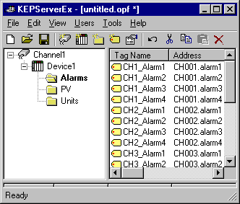
No sub group specified.
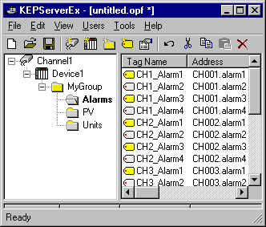
Sub group named"MyGroup" specified.
The "Auto Create" button allows you to manually initiate the creation of automatically generated OPC tags. If you modify the configuration of your device and want the communications driver to reevaluate the device for possible tag changes, pressing the "Auto Create" button will force this to occur. The "Auto Create" feature can also be accessed from the System Tags for this device allowing your OPC client application to initiate tag database creation.
Ethernet Encapsulation

What is Ethernet Encapsulation?
Like any great piece of new technology it's important to understand what it is before one can determine how to use it, but before we dig into what Ethernet Encapsulation is let's start with a possible real world scenario.
You arrive at the plant one day, check the work order and find that the IT department wants to gather data from each machine on the plant floor, and they want it quick. The IT guys think this will be easy since they dictated that Ethernet cabling be strung through out the plant. Unfortunately all of your existing PLCs only have serial connections.
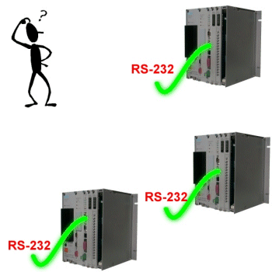
In the not too distant past, you would have had to contemplate running new wiring to each PLC, assuming the distances weren't too far. Another option would have been to use costly radio modems. Still, you knew there had to be a better way using the plants existing Ethernet wiring.
That's where terminal servers from companies like Digi and Lantronix come to your rescue. A terminal server is essentially a virtual serial port. More importantly, a virtual serial port that can sit on your existing Ethernet network.
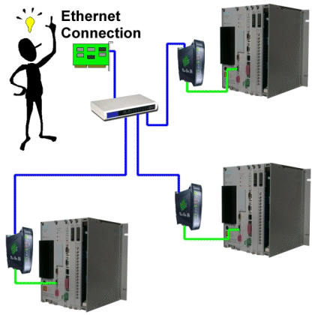
After learning of terminal server devices, you begin to breath a little easier. The task of connecting all of your controllers just took a big step back into the realm of reality. You will be able to place a terminal server next to each machine gathering operational data directly from the serial ports of the controller, and bring that data back to the IT guys via their Ethernet cabling. Problem solved and you're a hero (until tomorrow).
Now that you have an idea of what type of problems can be solved by using a terminal server device, we can explain what Ethernet Encapsulation is and how Kepware has added this technology to make your job easier. If you are already familiar with terminal servers, you may also know that many of them supply accompanying software that allows the terminal server to appear like a serial port to your operating system. This software can make using a terminal server very easy and wouldn't have required Kepware to make any changes to our software, except for one thing - timing.
Many of the devices in the industrial market have very complicated protocols. A protocol is a specification that determines how we talk to the device. In many cases there are also some very tight timing requirements that must be met in order to successfully communicate with the device. Taking these things into consideration, the software that often accompanies terminal server devices has not been optimized to work with the requirements of the plant floor environment. This is usually seen as frequent communications errors, continuous breaks in the communications, and long delays while the supplied software reconnects to the terminal server. All of these problems can make your use of a terminal server less than ideal.
Ethernet Encapsulation
Ethernet Encapsulation is the enhanced ability of KEPServerEX serial drivers to communicate directly with terminal servers. As described in the previous section, we could have used the software supplied with the terminal server, but this would not have yielded the most optimal result in terms of performance or reliability. With this in mind, Kepware has incorporated the functions needed to directly connect to a serial device connected to an Ethernet based terminal server.
If you are familiar with our serial drivers, you already know we let you select a serial port number from 1 to 100 when configuring a channel. For drivers that support Ethernet Encapsulation you will now find that you also have the option of selecting "Ethernet Encapsulation" mode. The following dialog demonstrates how this selection is presented:
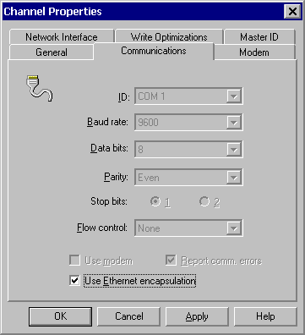
Configuring the channel for Ethernet Encapsulation mode is only half of the story. As with any Ethernet based connection you must also specify an IP address, a port number, and the Ethernet communications format to be used. This is done when you add a new device to your channel.
When a new device is added to the channel, the Ethernet Encapsulation settings will allow you to select an Ethernet IP address, an Ethernet Port number, and the Ethernet protocol to be used. The device dialog for Ethernet Encapsulation appears as follows:
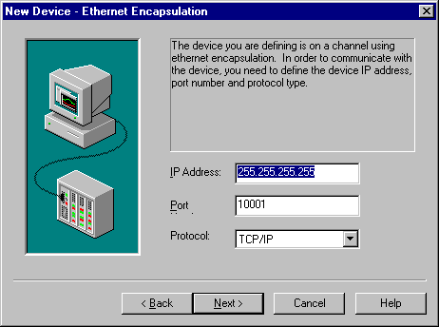
This dialog appears on the properties of each device you add to a channel in Ethernet Encapsulated mode. Since this dialog appears for each device, you can have hundreds of serial devices connected to your Ethernet network.
Important Note: When you select Ethernet Encapsulation mode you will notice that the serial port settings such as baud rate, data bits, and parity become greyed out. This occurs because these settings will not be used in Ethernet Encapsulation mode. The terminal server you are using must ,however, have its serial port properly configured to match the requirements of the serial device you plan to attach to the terminal server.
Visit our OPC Server List page to determine if the driver you need supports this feature. If you have further questions regarding how Ethernet Encapsulation works or how you can use it to solve your next tough communications task, please contact us. If it sounds like Ethernet Encapsulation is your ticket to beating your next connectivity challenge, download our free demo version of KEPServerEX and give it a try.
Note: Ethernet Encapsulation mode has been designed and tested using the Digi IA Series, and the Lantronix DR1 CoBox. The features developed will also work with other terminal server devices that support operational characteristics similar to the products listed above. If your terminal server supports a raw TCP mode it should work with this feature.
Go to the KEPServerEX Features Page »»
Configure Digi One SP for Use with Your KEPServerEX Project
Channel Diagnostics

KEPServerEX's diagnostic feature provides real-time data on the performance of your communication driver. All read and write operations can be viewed in the diagnostic display window of KEPServerEX or can be tracked directly in your OPC client application by using its built-in diagnostic tags. These diagnostics make it easy to debug tough communication issues. The diagnostics display window also provides a real-time protocol view. Given that KEPServerEX is on-line full time, you can view the real-time protocol window while you make changes to key communications parameters like baud rate, parity, or device IDs. As you make changes to your communications parameters you'll see the effect on communications in real-time, and once you set the correct communication and device settings, you'll immediately see the exchange of data with your device.
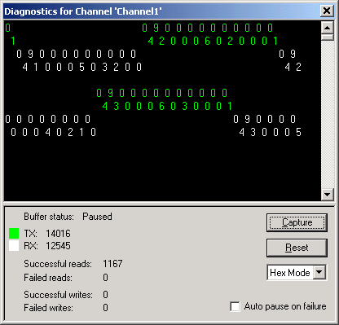
View the Channel Diagnostics Viewlet Demonstration for more information on Channel Diagnostics. You can also can get more indepth information about the Channel Diagnostics here or you can download KEPServerEX's help file and refer to the Diagnostics section.
Using OPC Diagnostics

What is OPC Diagnostics?
The OPC Diagnostics window provides a real-time and historical view of OPC events that occur between any OPC client and the server. OPC diagnostics logs an event which is a method call that a client makes into the server, or a callback the server makes into a client. The importance of OPC Diagnostics is that it allows Programmers and Support Technicians at Kepware to see how the customers client application is gathering data from the server. This is important when Kepware is not able to reproduce the issue that is seen on site. The rest of this document is a brief explanation of how to capture OPC Diagnostics in the server.
Setting Up OPC Diagnostics
To start you will need to open the OPC Diagnostics view by clicking on View|Diagnostics|OPC in the KEPServerEX Main Menu
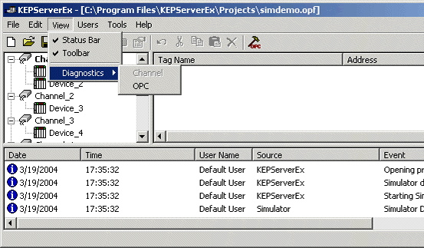
By default the OPC diagnostics window will open in standby mode. To start capturing diagnostics you would select the start button in the button menu bar. You can also select Tools|Options from the Main menu and change the default behavior.
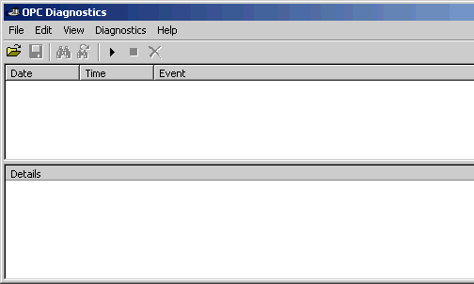
In the Options dialog you can set the OPC Diagnostics to start capturing on startup. You also choose to change whether or not you wish to change the default settings to Preserve the current diagnostics capture on your hard disk upon shutdown. Lastly, you can set the maximum number of OPC transactions to capture. The range is 1000 – 30000 transactions and the default is 5000. The number of transactions does not include the details of each transaction as they could be extensive.
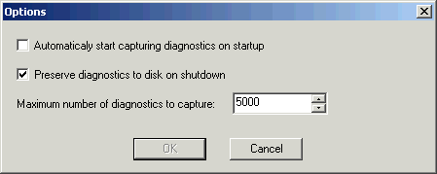
In some cases you may want to limit the OPC Diagnostics capture to specific events. This can be done by selecting Diagnostics|Filter from the Main menu and then un-checking the events that you do not want.
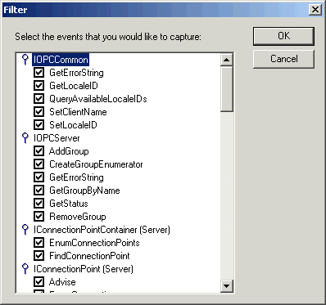
Capturing the OPC Events
Now we will do a simple connection to the server with the OPC Quick Client to see what happens. For this example we used the Simdemo project that is provided with the server when it is installed
First you need to click the Start button in the Button Menu to start capturing diagnostics.
Next, manually start the OPC Quick Client from the ‘Start Menu | Kepware Products’ and selecting OPC Quick Client. Connect to the server by creating a new server connection. In the diagnostic window you can see the OPC events that are triggered.
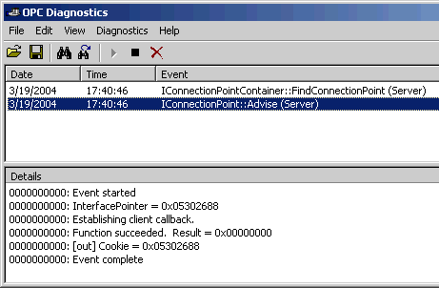
Next in the OPC Quick Client add an OPC Group. Again go back to the OPC Diagnostics window and you can see the specific events that are triggered.
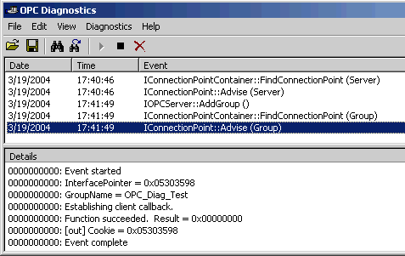
Once the group has been added you can then add an item to the group. You can add the item manually or browse the server for the item. As you can see by looking at the OPC Diagnostics window below, and by looking at the first event, that we had browsed the server for our tags. You will see that you get a Data Change event triggered as soon as the item is added.
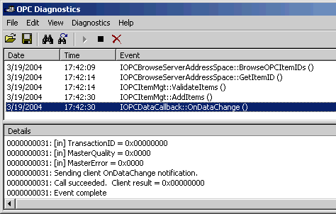
Lastly, some of the details of a data change event.
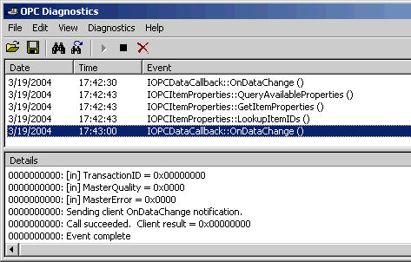
When enabled, the OPC Diagnostics will capture every OPC event that has not been filtered out until it captures the specified maximum number of events.
The Complete View
If an issue arises you can capture your OPC diagnostics and send them to Kepware for troubleshooting purposes. This is done by selecting File|Save As in the Diagnostics Main Menu. You will have two options. You can save the capture in the default binary file format, which can be large but can be opened in the Diagnostics view at a later date. The other option is to save it as a text file which is much smaller and can be printed if needed.
Note: If you save the diagnostic capture as a binary file, then you can open it in the Diagnostics view and at any time, and then you can save and copy as a text file for printing. However, if you save it as a text file you cannot open it back up in the Diagnostics view.
Sample OPC Diagnostics Text File
3/19/2004 17:40:46 IConnectionPointContainer::FindConnectionPoint (Server)
0000000016: Event started
0000000016: InterfacePointer = 0x053054F0
0000000016: [in] REFIID = IID_IOPCShutdown
0000000016: Function succeeded. Result = 0x00000000
0000000016: [out] ConnectionPoint = IID_IOPCShutdown
0000000016: Event complete
3/19/2004 17:40:46 IConnectionPoint::Advise (Server)
0000000000: Event started
0000000000: InterfacePointer = 0x05302688
0000000000: Establishing client callback.
0000000000: Function succeeded. Result = 0x00000000
0000000000: [out] Cookie = 0x05302688
0000000000: Event complete
3/19/2004 17:41:49 IOPCServer::AddGroup ()
0000000016: Event started
0000000016: InterfacePointer = 0x05304F20
0000000016: [in] Name = OPC_Diag_Test

OPC Quick Client

KEPServerEX includes an extensive OPC Quick Client application to aid in the development of your OPC applications. The Quick Client is a full-featured OPC client that supports all of the operations available in any OPC client application. Using the Quick Client you can access all of the data available in your server application including system, diagnostic, and user defined tags. The Quick Client allows you to read and write data, perform structured test suites, and test server performance. The Quick Client's comprehensive error reporting provides detailed feedback regarding any OPC errors returned by the server helping diagnose common OPC Client/Server issues.
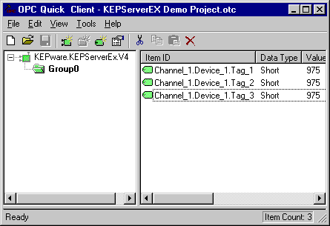
For more detailed information on Kepware's OPC Quick Client check out the Quick Client Connectivity Guide and the Quick Client Help File. Also check out the 'Testing the Project' section in KEPServerEX's help file.
KEPServerEX Visual Basic OPC Client

KEPServerEX's goal is to make using OPC technology easier regardless of the type of OPC client application you may be using. For many of your applications, Microsoft's Visual Basic provides an ideal environment to create custom industrial applications. Until now using OPC technology in your Visual Basic application might have left you with more questions than answers. The simple and complex VB examples included with KEPServerEX are well commented and provide additional pointers for using OPC servers in your VB applications. The complex OPC example implements a complete OPC test client in VB with the ability to handle multiple OPC servers, multiple OPC groups, and multiple OPC tags. No example of OPC technology would be complete without OPC tag browsing and the complex example gives you a complete tag browsing interface. All of the source code for these examples is provided in the KEPServerEX download.
