 Product Information

Version 4.0

11/01/01
Setting Up and Using Your Kepware Products
Summary
OPC (OLE for Process and Control) servers provide a standardized method of allowing multiple industrial applications to share data in a quick and robust manner. The OPC server and LinkMaster products provided in this package have been designed to meet the demanding requirements found in the industrial environment.

This OPC server has been designed as a two-part program. The primary component provides all of the OPC and DDE connectivity as well as the user interface functions. The second part is comprised of plug-in communications drivers. This two-part design allows you to add multiple communications options to your SCADA application while utilizing a single OPC server product thus reducing your learning curve as your project grows.

LinkMaster has the capabilities of both a "server" and a "client" application, allowing it to access, collect, organize, and link data from other OPC servers and offer that data to any OPC/DDE client. It provides the means of linking data between OPC servers; thus, acting as a universal bridge for OPC server/client components.

OPC technology reflects the move from closed proprietary solutions to open architectures that provide more cost-effective solutions based on established standards.
Installing the OPC Server on Your PC
The following instructions will explain how to install the server and drivers on your PC.
- Place the provided Kepware Products CD-ROM in your CD drive. The CD should automatically run the installation front end. If it does not then browse your CD drive in Explorer and double click on “Autorun.inf”.
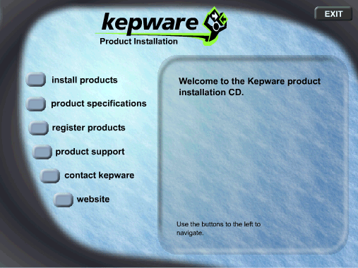

- Click on the Install Products button to open the product installation page.

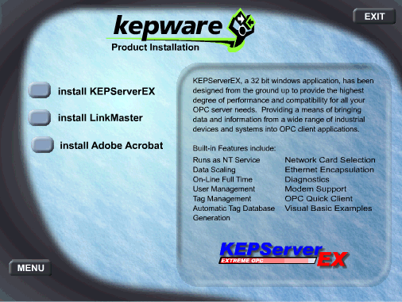

- Click on the Install KEPServerEX button to start the server installation.
- In the Installation Welcome Dialog box click the Next button to continue.
- Read the License Agreement and then click the Yes button to accept it and continue.
- By default the Server will install to folder directory “C:\Program Files\KEPServerEX”. Either change the installation location or click the Next button to accept the default and continue. If you already have the server installed then this will upgrade the current version. See Upgrading your product for more details.

- The CD contains every driver available in the server. Select the driver or drivers you wish to install by placing a checkmark in front of the driver in the list. To install all drivers press the Select All button. If you are installing a driver suite you must select all the drivers in that suite.
- When you are done selecting drivers, click the Next button to accept the selections and continue.
- By default the installation creates a Start Menu folder named KEPServerEX. Either change the folder or click the Next button to accept the default and continue.
- Verify the selected installation options and then click the Next button to accept the default and continue.
- Once the Installation is complete click the Finish button to acknowledge and then close the CD install application.
Installing LinkMaster on Your PC
The following instructions will explain how to install LinkMaster on your PC.
- Place the provided Kepware Products CD-ROM in your CD drive. The CD should automatically run the installation front end. If it does not then browse your CD drive in Explorer and double click on “Autorun.inf”.

- Click on the Install Products button to open the product installation page.

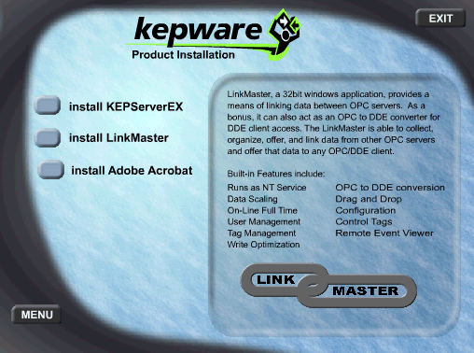

- Click on the Install LinkMaster button to start the installation.
- In the Installation Welcome Dialog box click the Next button to continue.

- Read the License Agreement and then click the Yes button to accept it and continue.

- By default LinkMaster will install to folder directory “C:\Program Files\Linkmaster”. Either change the installation location or click the Next button to accept the default and continue. If you already have LinkMaster installed then this will upgrade the current version. See Upgrading your product for more details.
- By default the installation creates a Start Menu folder named LinkMaster which will be located in the Kepware Products Folder. Either change the folder or click the Next button to accept the default and continue.
- Verify the selected installation options and then click the Next button to accept the default and continue.
- Once the Installation is complete click the Finish button to acknowledge and then close the CD install application.
Upgrading Your Product
The current version of the KEPServerEX can always be found at www.kepware.com. Upgrading to the newest version is as simple as downloading the current demo and installing it over your current install. The install set will automatically upgrade those files that need upgrading. Your license and project files are completely safe. Free upgrades are provided within a product generation only. Contact Kepware if you have any questions.
Licensing and Registering a Driver
The following describes the 2 step process required for installing a license on a PC and then Registering it for an unlock code.
- If the server is not already running then you should start it now.
- From the Server main menu click on Help|Purchase a Driver or Plug-in License…, as indicated by the arrow.
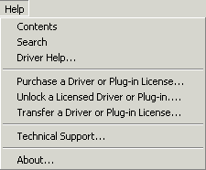

- In the Unlicensed Drivers and Plug-ins dialog box, select the product you wish to license and click on the License… button .
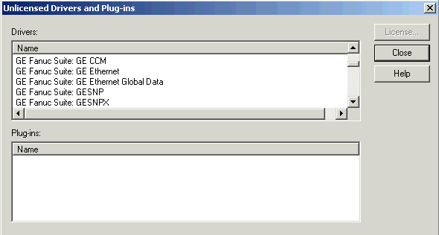

- You will now be asked to enter the Serial Number for the Driver or Suite License you ordered. This number can be found on the OPC Server License Key label that came with your software. Enter the number and click OK.
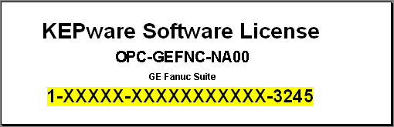

- If the S/N is valid you will get confirmation that the driver (or drivers if licensing a suite) has been entered and now must be unlocked and registered.
- To register the drivers you may answer yes to the dialog prompt to start or answer no and later from the Server main menu Select Help|Unlock a Licensed Driver or Plug-in…, as indicated by the arrow.
- If you are unlocking a driver suite then you will see all of the drivers in that suite, and you should select one of the drivers and click the Register… button . Otherwise you will open directly the registration/driver unlock window.
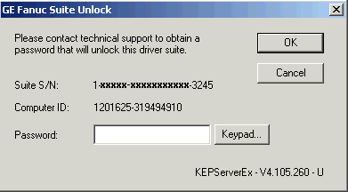
- You will see your driver unlock window, which displays the S/N that you entered and a Computer ID, in newer versions you will also see the Server Version number. You will need to 1)Call 2)Fax or 3)E-mail (password@kepware.com) Kepware with the License/Serial Number, the Computer ID, and the server version number so that a password can be generated for you. If you are not the original purchaser or are unlocking for a client then we will also need contact information.
- Enter the password and click OK to accept it.
- If you provided the correct numbers and in turn entered the password correctly you should now get verification messages that the driver or drivers have been successfully unlocked.
- Now stop and restart the server project so that the license will take effect.
Transferring a License
As you may have noticed we do provide the ability to transfer a registered license to another PC. You cannot transfer a license that has not been registered. The following steps explain how to transfer a license. Detailed instructions on how to transfer a license can be found in the Server help file.
- The transfer process will always start on the PC that the license will be transferred to. We will refer to this PC as the Target PC.
- First make sure the server and appropriate driver (or drivers if a suite) is installed on the Target PC.
- Next start the Server and in the Server main menu select Help|Transfer a Driver or Plug-in License… .
- Follow the instructions in the License Transfer Wizard.
- Accept the License Agreement. If you do not accept it the transfer will be ended.
- Select the Target Option and then select the driver license you will be transferring.
- Next you will select the floppy drive where you will prepare the transfer diskette and click the Prepare button.
- Once the diskette has been prepared, remove it from the floppy drive and take it to the PC containing the registered license. We will refer to this as the Source PC. You must leave the Wizard open on the Target PC.
- Insert the diskette into the floppy drive.
- On the Source PC run the server but do not select a project. Select Help|Transfer a Driver License… from the Server main menu.
Note: If the Transfer option is greyed out check to see if a software client is connected to the server, a project is loaded with the driver, or the license was never registered. The problem will have to be corrected to continue.
- You will need to accept the License Agreement again.
- Next select the Source option and select the driver license you will transfer.
- Next you will prepare the diskette for the Target PC. This function will move the license to the floppy disk.
- Once the process is complete remove the diskette and place back in the floppy drive of the Target PC.
- Complete the steps to transfer the license from the diskette to the Target PC.
- The transfer process is complete. Your driver should be fully registered.
KEPServerEX Documentation
You can obtain detailed information on the server and how it functions by clicking on the Product Support button in the Kepware installation menu. You can open the help file by clicking on the On-Line Help button indicated by the arrow.

Next click on the White Papers Button to see a list of the available white papers and to open the KEPServerEX Help file.

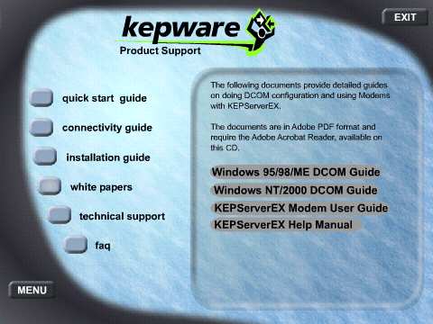

Once you install the server and drivers you can view the server help by selecting Help|Contents or Help|Search in the server main menu. Driver help can be selected from the Server Help menu.
Driver Documentation
The driver help files provide the information needed to establish communications to the devices supported by that driver. The help files contain cable diagrams, Communications parameters, and I/O address formats. To make connectivity easier, most drivers have been designed to use the factory defaults on start up.
Third Party Client Software
Also provided in this installation CD is Kepware’s OPC Connectivity Guide. This guide contains details on how to connect to the server from third party clients like RSView, Cimplicity, Genesis, PanelMate PC, Think n’ Do, Intouch, iFix32 and WinCC. These are a few of the many OPC clients that can connect to this server. The document is in Adobe PDF file format, clicking on the Installation Guide button in the Product Support Menu will open the file.

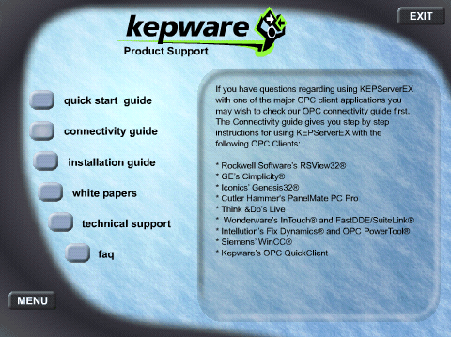

Note: We also provide an install for the Adobe reader if you do not have it installed on your PC.
Help Information
Please refer to the following sources for useful help information:
  - The Driver help files contain basic information on setting up the devices for communications, supported device addresses, as well as detailed descriptions of error codes and possible solutions.
  - The Server help file provides you with information on the various components and wizards in the server.
  - The OPC Connectivity guide provides basic information on connecting to the server from 3rd party client software.
  - Lastly, you will find guides and trouble shooting tips on our web site at www.kepware.com.

System Requirements

Minimum
Operating System: Windows 98*
Processor: Pentium 200 MHz
Ram: 32 Megs
Disk Space: 10 Megs
Microsoft Internet Explorer 5.0 or newer

Recommended
Operating System: Windows NT 4.0 SP5 or better
Processor: Pentium 400 MHz
Ram: 64 Megs
Disk Space: 10 Megs
Microsoft Internet Explorer 5.0 or newer

*The server is designed to run on Windows 95, 98,NT 4.0, and all versions of Windows 2000. On Win 95 and some older Win98 PC’s you will probably have to load the Microsoft DCOM patch since DCOM is not native to them.

